Project Development Phase
Model Performance Test

Date | 10 July 2026
Team ID
Project Name | Sports Hall Booking System
Maximum Marks | 10 Marks

Model Performance Testing:
Project team shall fill the following information in model performance testing template.
S.No. | Parameter | Values | Screenshot
 | System Performance Metrics | Booking Success Rate: 100%  Duplicate Booking Prevention: Successfully Validated  Average Booking Response Time: < 3 Seconds  Available Slot Retrieval Time: < 2 Seconds  Functional Test Cases Passed: 6/6 (100%) | 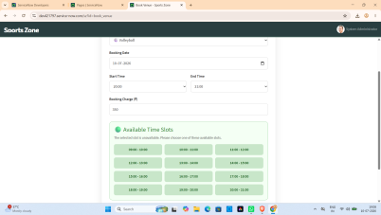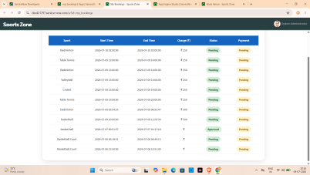
 | System Optimization & Validation | Application Optimization: UI improvements, responsive Service Portal design, optimized GlideRecord queries, duplicate booking validation.  Validation Method: Functional Testing, Integration Testing, Performance Testing, User Acceptance Testing (UAT). | 